## Problem 1 – Info Panels

Create a Web page (HTML5 + CSS3 + images) that looks and behaves like the screenshots below:

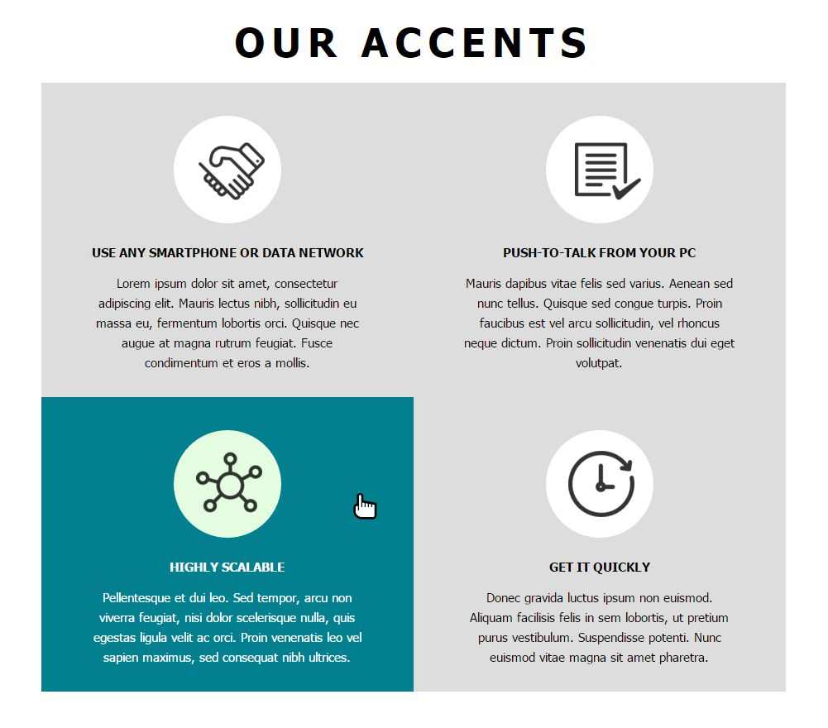

* The mouse cursors in the above screenshots explain what happens when the mouse moves over a project or a group and when the browser window resizes.

### Input

You are given the above screenshots + all required images + the texts on the site.

### Output

The output should be valid HTML5 + CSS3 + images that implement the above Web page.

### Constraints

* The layout should be 900px.
* Font: 15px/24px Tahoma, sans-serif; Main Heading font: 48px/60px;
* The site should open correctly in Chrome 35.
* Pixel-perfect implementation is not required.